

Virtual Power Plant Framework for Distributed Energy Sources

A Digital Twin Consortium White Paper
DRAFT STATE
YYYY-MM-DD

Authors
Daniel Young(Toshiba America, Inc.), Tim Farnam(Toshiba Europe, Ltd.), John Reynolds(Agile Fractal Grid)

Contents
Introduction 3
Purpose 3
VPP Architecture Elements 4
Common Architecture Components 8
Regional Comparisons 13
Common Metrics 15
Stakeholders 17
Example Use Cases 17
References 20
Authors & Legal Notice 21

Figures
Figure 1-1: VPP Energy Balancing System. Source: DTC Energy Solutions Working Group. 6
Figure 6-1: Three Tier IoT Distributed Energy Resource. Source: DTC Energy Solutions Working Group. 8

Tables
Table 7-1: Digital Twin Framework Components. Source: DTC Energy Solutions Working Group. 8
Table 7-2: VPP Data Usage. Source: DTC Energy Solutions Working Group. 9
Table 7-3: Sample Table with centered heads, left aligned text and sub-bullets. 9

Introduction
Virtual Power Plants (VPPs) offer a flexible and scalable framework to modern energy systems, supporting real-time visibility, predictive analytics and dynamic coordination of decentralized energy assets. This not only enhances grid stability and flexibility, but also opens new value streams for utilities, aggregators and end-users. This framework facilitates interoperability among energy generators, energy trading markets and electric grid operators, enabling new opportunities for efficiency, resilience and value creation.
The aim of this document is to highlight the global benefits of VPPs in addressing energy variability, grid stability and market integration for a cleaner, more resilient energy future.

Purpose
A Virtual Power Plant (VPP) integrates Distributed Energy Resources (DERs) into a cohesive and manageable virtualized energy network. Aggregating renewable energy providers and utilizing demand response capabilities allows VPPs to create stable and efficient power systems, This orchestration of decentralized energy resources through a system-of-systems (SoS) approach addresses energy variability, improves grid stability and facilitates market integration, ultimately providing clear value to all stakeholders involved by promoting decarbonization efforts, enhancing disaster prevention and fostering a new renewable energy market.
Beyond supporting sustainability and renewable energy integration, Virtual Power Plants also serve a range of critical functions that enhance the efficiency and resilience of modern power systems. Key goals include strengthening grid reliability by enabling rapid response to outages and voltage fluctuations and managing peak demand to reduce strain on infrastructure and defer capital investments. VPPs also support economic optimization by participating in wholesale energy markets and enabling energy arbitrage and demand response monetization. They empower end users (commercial and residential) with greater control and flexibility over their energy usage, while optimizing the performance and lifecycle of distributed energy assets. Additionally, VPPs enhance disaster preparedness and recovery through decentralized energy support and scalable, modular expansion of grid capabilities. Collectively, these capabilities position VPPs as essential tools for building a more resilient, efficient and customer-centric energy future.

VPP Architecture Elements
The generalized VPP architecture is described in Figure 1.
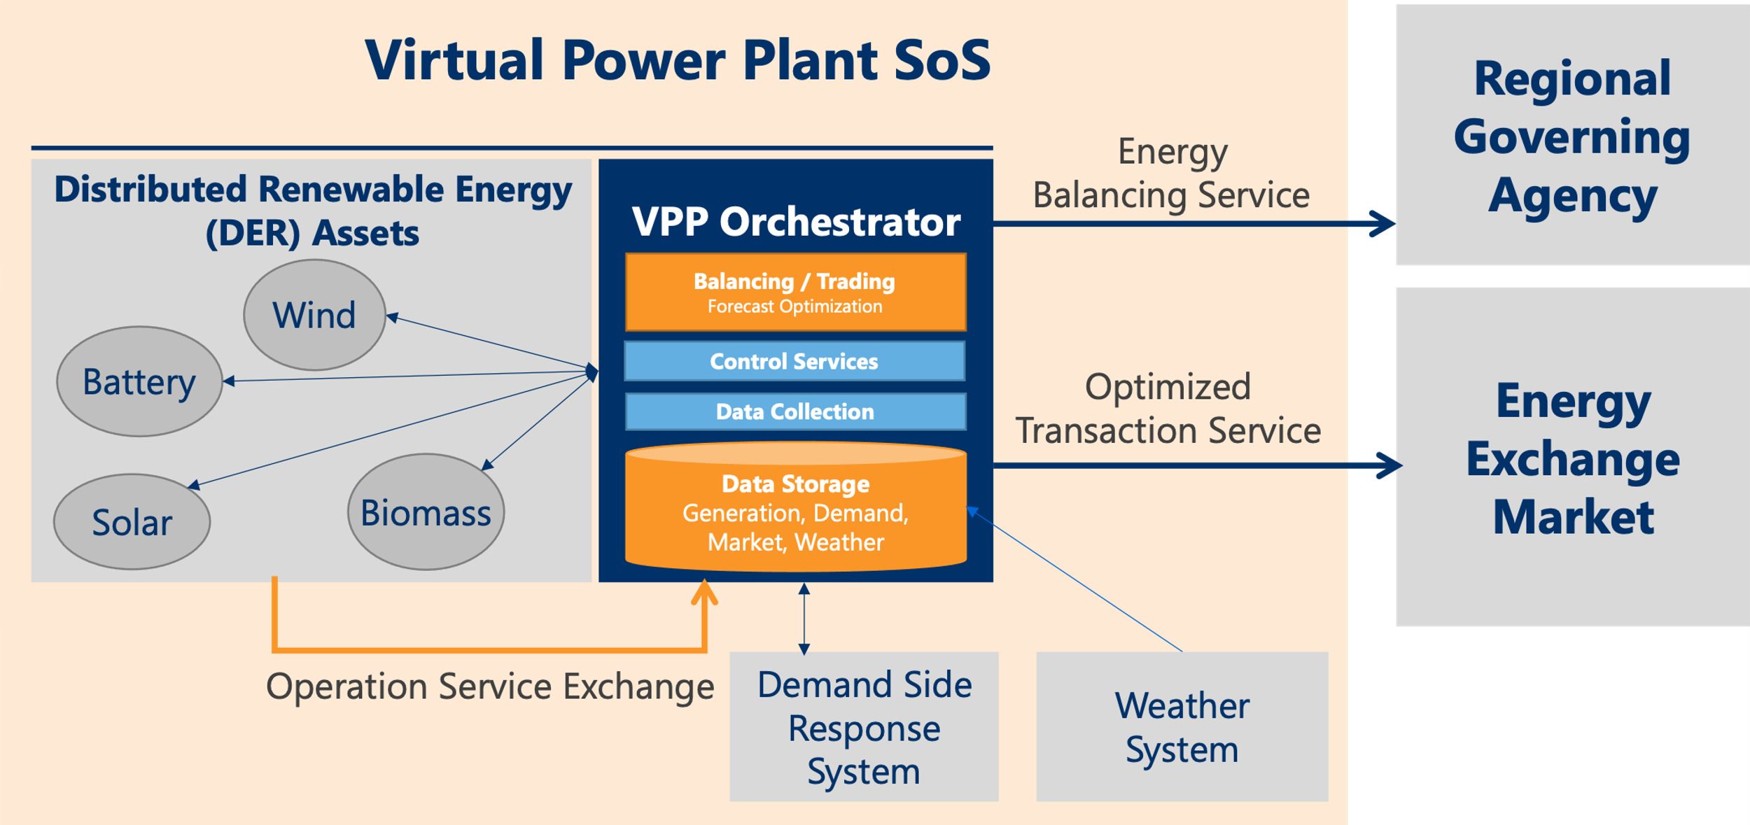
Figure 1: VPP Energy Balancing System. Source: DTC Energy Solutions Working Group.

Common Architecture Components
The common architecture components are described below:

Distributed Energy Resources (DER)
These are the physical, geographically dispersed energy generation, storage and flexible load resources (some examples include: photovoltaic panels, wind turbines, battery storage systems, biomass) that participate in the VPP as independent, distributed energy assets. They are equipped with local control capabilities and IoT instrumentation and their operation is independent of the overall Structured Energy Balancing System. They contribute capacity, flexibility and localized response to grid conditions.

Digital Twins of Distributed Energy Resource Assets
These digital twins may be physics-based or AI-enhanced virtual representations of DERs, replicating both their synchronized behavior, status, surrounding environment, and operational constraints. They enable simulation, forecasting and optimized control strategies without interfering with real-world operations.

SEB Orchestrator
The core intelligence layer of the VPP, the orchestrator receives input from forecasting, optimization and real-time monitoring services. It determines dispatch schedules, coordinates DER participation, executes control strategies and ensures alignment with grid and market requirements. It integrates with internal and external systems to manage system-wide behavior.

Demand Side Response System
This system enables active control of flexible loads such as HVAC, industrial equipment or commercial lighting systems. It receives signals from the SEBS orchestrator to reduce or shift demand in response to grid conditions, pricing incentives or market events. It may support both automated and manual participation by end users.

Weather System
A forecasting service that supplies real-time and predictive weather data. It informs renewable generation forecasts (e.g., solar irradiance, wind speed) and demand predictions (e.g., temperature-driven HVAC loads). This system improves the accuracy of DER scheduling and risk mitigation strategies.

Energy Balancing Service
This module calculates the net energy balance across all assets and loads in the VPP and ensures real-time and scheduled alignment between supply and demand. It executes algorithms for optimal resource dispatch, load balancing and curtailment based on forecasted and actual conditions.

Optimized Transaction Service
Handles economic dispatch optimization by translating technical schedules into market transactions or contractual obligations. It ensures that dispatch plans maximize economic return while complying with operational constraints, regional regulations and service-level agreements.

Energy Trading Forecast Optimization Service
This component integrates energy market price forecasts with generation/load predictions to determine optimal bidding strategies for day-ahead, real-time or ancillary services markets. It enhances VPP revenue streams through intelligent market participation.

Control Services
Responsible for sending real-time control signals to DERs and receiving status updates. It implements commands from the SEB orchestrator, such as setpoints for inverters, battery charge/discharge commands or load curtailment triggers, ensuring safe and compliant execution.

Data Collection
Collects high-frequency telemetry and event data from distributed assets, sensors, meters and edge devices. It performs initial filtering, normalization and tagging to prepare data for analytics, visualization and archiving.

Data Storage
Provides persistent storage of operational, historical and transactional data using time-series databases, event logs and document stores. It supports traceability, compliance and machine learning training sets for forecasting and optimization modules.

Operational Service Exchange
A service bus or integration framework that manages communication between all VPP components using secure, standardized messaging protocols. It ensures real-time interoperability between modules, including orchestrator, trading systems, control services and external stakeholders (e.g., TSOs, DSOs, aggregators).

IoT Devices, Data Flow and APIs
In addition to these architectural components, it is also important to consider these additional elements:

IoT Devices and Data Flow
IoT sensors, meters and gateways collect real-time operational data (e.g., power output, temperature, state-of-charge) from DERs and transmit it through secure communication networks for analysis and control. This data flow underpins situational awareness and responsive operations.

APIs for External Systems
These interfaces expose VPP capabilities to utilities, market operators and regulatory entities via standardized protocols (e.g., OpenADR, IEEE 2030.5, IEC 62056). They support integration with grid management systems and participation in energy markets.

APIs for Internal Components and Constituent Systems
These APIs facilitate communication among internal subsystems such as forecasting engines, optimization modules, DER controllers and SCADA integration layers (e.g., IEC 61850, IEC 60870-5-104, OPC_UA). They ensure modularity, scalability and interoperability within the VPP architecture.

Artificial Intelligence Components
These components includes AI/ML-based forecasting for load, generation and weather; optimization engines for dispatch and market bidding; and control logic for executing demand response and energy trading strategies. It is the intelligence layer of the VPP.
Examples here include: Predictive Analytics, Balancing and Trading Optimization, Demand Side Response, Weather Prediction

System Platform Infrastructure
The cloud and edge computing resources, data storage, messaging brokers and runtime environments that host the VPP orchestration functions and analytics. This infrastructure ensures reliability, elasticity and operational continuity.

Security Protocols and Regulatory Standards
This includes identity management, encryption, audit logging and compliance with industry standards (e.g., NERC CIP, ISO/IEC 27001, IEC 61850). It ensures secure operations, data privacy and alignment with energy sector regulations.

System Architecture Key Characteristics
The System Architecture combines elements of the IIRA v1.10 “System-of-systems Architecture Pattern”[1] and the “Three Tier IoT Distributed Energy Resource System Pattern”[3], as shown in Figure 2 and Figure 3.
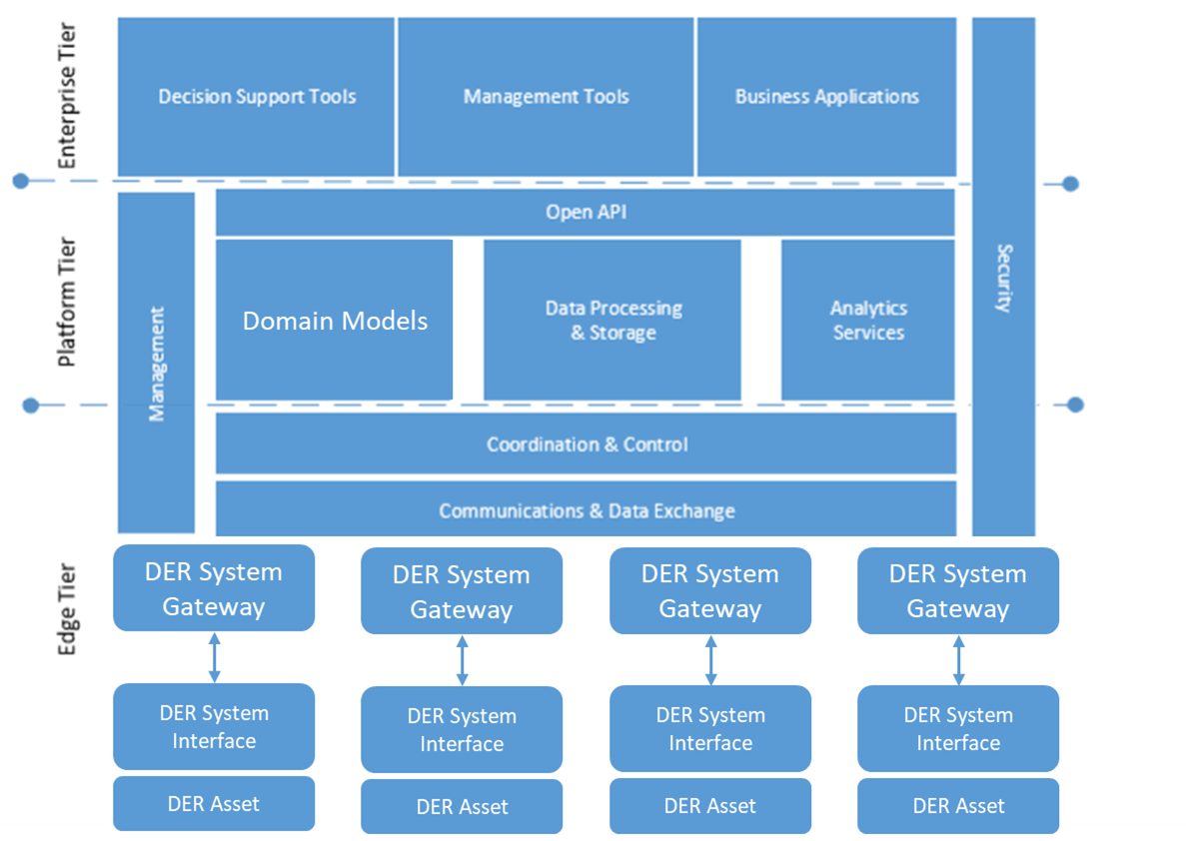
Figure 2: Three Tier IoT Distributed Energy Resource. Source: DTC Energy Solutions Working Group.

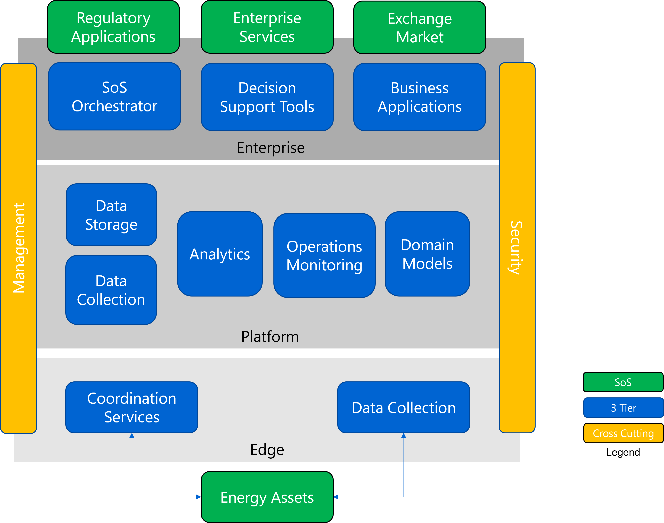
Figure 3: VPP 3-Tier Architecture Mappings. Source: DTC Energy Solutions Working Group.

VPP System-of-systems Characteristics
VPPs exhibit core System-of-systems characteristics: it involves multiple stakeholders with independent objectives, heterogeneous system capabilities and emergent functionality enabled through coordination. Drawing from the DTC “System-of-systems Model for Value Creation” [2], the VPP can be viewed as a structured system-of-systems, supporting analysis of how distributed energy assets, digital infrastructure and operational services interact to deliver coordinated outcomes.

Stakeholders
Energy Aggregators
Utilities and Grid Operators (e.g., TEPCO, ERCOT, CAISO, etc.)
Regulators and Policy Makers (e.g., METI, FERC, OFGEM)
Technology Providers
End-Users / Prosumer Communities
Battery and DER Manufacturers

System Capabilities

Aggregation of Distributed Energy Resources
Ability to treat solar panels, wind turbines, energy storage systems (batteries) and controllable loads (demand response) as a single virtual entity for coordinated management.

Decentralized and Flexible Operation
Enables distributed, adaptable energy systems, increasing resilience and reducing dependence on centralized power plants.

Scalability
Ability to incorporate additional DERs over time without significant disruption to existing operations.

Resilience
Robustness against disruptions by distributing energy production across various sources.

System Functionality

Real-Time Monitoring and Control
IoT devices and sensors provide continuous oversight of DER performance and enable dynamic optimization of energy production, storage and consumption based on grid demands.

Orchestration and Automation
Automation tools manage the coordination of DERs, optimize energy flows and perform energy trading with minimal human intervention.

AI and Predictive Analytics
Algorithms forecast energy demand, predict renewable energy generation and make optimization decisions in real time.

Value Delivery

Grid Services and Stability
Balancing energy supply and demand, frequency regulation, voltage control and peak shaving to help ensure grid reliability.

Market Participation
Collective participation of DERs in energy markets, allowing aggregated resources to trade electricity, provide ancillary services and engage in demand-response programs.

Outcomes and Benefits

Energy Efficiency and Decarbonization
Supports the transition to a decarbonized energy system, reducing reliance on fossil fuels.

Resilience
Enables quicker recovery in case of disruptions and mitigates risks associated with centralized energy production failures.

Decentralized and Flexible Operation
Increases system resilience and adaptability.

VPP Digital Twin Framework
The VPP can also be understood as a layered platform system, consistent with the DTC “Platform Stack Architectural Framework” [7]. It integrates infrastructure, edge, platform services, applications and interfaces to support orchestration, control, optimization and data-driven decision-making across a heterogeneous set of energy resources. Each layer supports different classes of functionality, from low-level data collection and device control to higher-level services such as market forecasting, demand response and predictive analytics. This architectural separation of concerns enables modularity, scalability and composability—key attributes for managing a dynamic, distributed energy ecosystem.
Digital Twin Framework Component | Structured Energy Balancing System Component | Explanation
Real-World | Distributed Energy Resources (DERs) | Physical DER Assets
Synchronization Mechanisms | IoT Devices and Data Flow | Real-time data exchange between physical DERs and digital models.
Virtual Representation | Digital Models of DERs | Computational models of DERs, along with related structured/unstructured data
Service Interfaces | APIs for external systems | Service interfaces for grid management and other external services
Integration Service Interfaces | APIs for internal components and constituent systems | Synchronizes between the real-world DER and its virtual representation, allowing aggregation of DERs into the SEBS
Applications (Analytics and Other Services) | Predictive Analytics, Balancing and Trading Optimization, Demand Side Response, Weather Prediction | Tools for predicting, optimizing and automating grid operations.
IT/OT Platform | System Platform Infrastructure | Infrastructure supporting the SEBS, including networking, storage and computing.
Security, Trust, & Governance | Security Protocols and Regulatory Standards | Ensures privacy, security and resilience of the SEB system.
Management and Automation | SEB Orchestrator | Coordinates between DERs, grid operations and market participation.
Table 1: Digital Twin Framework Components. Source: DTC Energy Solutions Working Group.

VPP Digital Twin Capabilities
When analyzed through the lens of the DTC “Capabilities Periodic Table” [8], the VPP requires a range of digital twin capabilities across multiple categories, including sensing, simulation, coordination and autonomy. These capabilities are deployed across platform layers and distributed across constituent systems, enabling the VPP to function as both an orchestrator of energy assets and an intelligent participant in larger grid and market structures. As these capabilities evolve, they inform the system’s ability to deliver value not just through operational execution, but through adaptability, resilience and continuous learning.
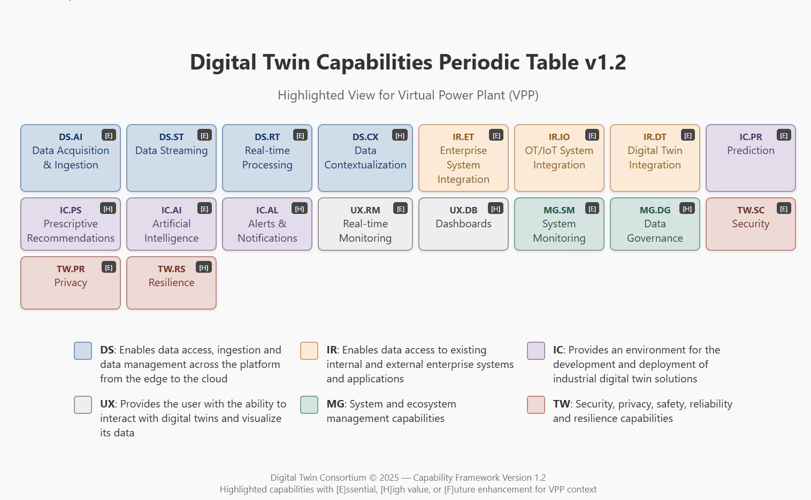
Figure 4: VPP Digital Twin Capabilities. Source: DTC Energy Solutions Working Group.

Common Metrics
There are metrics that help provide standardized ways to assess system effectiveness across technical, economic and operational dimensions; they support benchmarking, regulatory compliance and continuous improvement efforts. This section outlines some common metrics used to monitor and optimize VPP performance.

Data Usage
Data Source | Data Content | Data Usage
Distributed Energy Resources (DERs) | Generation output, battery levels, consumption | Energy forecasting, grid balancing, storage optimization
IoT Devices and Sensors | Power output, grid frequency, environmental conditions | Real-time monitoring, fault detection, grid stability management
Weather and Environmental Data | Wind speed, solar irradiance, cloud cover | Renewable generation forecasting, demand response activation
Market and Grid Data | Electricity prices, market demand, grid constraints | Energy trading strategies, demand response, grid integration
Historical Performance Data | Past generation and consumption, battery cycles | Predictive analytics, demand prediction, market optimization
Regulatory and Compliance Data | Legal frameworks, emissions data, grid codes | Compliance reporting, operational adjustments
User and Consumer Data | Energy usage patterns, smart home data, load profiles | Personalized energy management, demand response management
Digital product passport data  + digital twin registries | Capabilities and efficiency of energy assets such as EV / batteries / operating modes | Estimation of degradation and impact, optimization and prioritization of use
Table 2: VPP Data Usage. Source: DTC Energy Solutions Working Group.

Qualitative Metrics
Improved coordination across decentralized energy assets.
Enhanced grid resilience during peak demand or outages.
Increased transparency and visibility for utilities and operators.
Reduced reliance on fossil fuel-based peaking power plants.

Quantitative Metrics
% increase in DER utilization or dispatch efficiency.
% improvement in forecast accuracy (e.g., solar/wind generation).
Reduction in energy imbalance costs.
ROI from energy market participation.
Number of avoided curtailments or outages.

Regional Comparisons
Each region has specific characteristics and advancements in various aspects, such as: Distributed Energy Resource (DER) Aggregation, Demand Response, Real-time Monitoring and Control, Digital Twin Technology, Frequency Containment Reserves (FCR), Market Participation, Predictive Analytics & AI, Communication Standards, Battery and Storage Integration and Grid Flexibility & Stability Services

USA
In the USA, VPPs focus on aggregating solar, wind, battery storage and electric vehicles (EVs). Demand response is integrated into wholesale markets and real-time monitoring and control are achieved through IoT and SCADA integration. Digital twin technology is increasingly adopted for grid simulation and predictive control. The USA participates in frequency and stability markets and has wholesale market access via RTOs/ISOs, such as FERC Order 2222. Predictive analytics and AI are used for forecasting and load balancing, with communication standards like OpenADR, Modbus and MQTT. Battery and storage integration occur at both utility and residential levels, providing grid services such as frequency regulation, peak shaving and load balancing.

Japan
Japan focuses on regulatory tariff changes, energy security, centralization and utility dominance, while the USA emphasizes market forces, grid flexibility, decentralization and state-by-state regulation. Both countries share common technological points, including digital twins, AI algorithms, IoT monitoring, real-time trading systems and demand response, which are essential for smart grid integration.
Japan's VPPs primarily aggregate solar, battery storage and EVs. Demand response is utility-led with a local focus, often coordinated through OpenADR. Real-time monitoring and control are IoT-enabled and AI-driven for precision. Digital twin technology is used for system optimization and real-time management. Japan supports grid stability, especially for disaster resilience and has limited market integration driven by utilities. Predictive analytics and AI are used for renewable forecasting, balancing and stability. Communication standards include OpenADR and IEC standards for interoperability. Battery and storage integration focus on residential storage and utility aggregation for stability, with grid services such as frequency control, renewable integration and grid resilience.

UK
In the UK, VPPs aggregate solar, wind (especially offshore) and battery storage. Demand response is actively used in balancing services with flexible market participation. Real-time monitoring and control utilize advanced IoT, SCADA and digital twins. Digital twin technology is widely adopted for grid simulation and optimization. The UK has a strong focus on FCR as part of dynamic containment programs and competitive market structures with capacity and balancing markets. Predictive analytics and AI are extensively used for real-time grid balancing and optimization. Communication standards include OpenADR, IEC standards and proprietary standards for utility applications. Battery and storage integration is significant at the residential level, providing advanced flexibility services.

EU
The EU shows high adoption in Northern Europe and emerging markets in Germany and the Nordic countries. VPPs aggregate a broad mix of solar, wind, battery storage and hydropower. Demand response is emerging in flexibility markets, with advanced use in Germany and the Netherlands. Real-time monitoring and control are mixed, with high adoption in Northern Europe and lower in Southern and Eastern Europe. Digital twin technology is increasingly adopted in Germany, the Netherlands and Nordic countries. The EU commonly uses FCR in balancing markets, particularly in Germany and Nordic countries. Market participation involves a unified energy market with cross-border trading and different regulations by country. Predictive analytics and AI are increasingly used for load forecasting and DER management in advanced markets. Communication standards are mixed, with OpenADR used alongside diverse standards based on country, including recent pilot deployments of IEEE2030.5, Universal Utility Data Exchange (UUDEX), Asset Administration Shell (AAS) and OPC UA for direct and aggregated asset connections. Battery and storage integration have high adoption in Germany, the Netherlands and Nordic countries, with growing interest in other EU regions. Grid flexibility and stability services include established flexibility services, particularly in Northern and Western Europe.
The EU is strategically addressing energy flexibility service provision with the recommendation that EU and national authorities and system operators should improve energy data management and flexibility solutions transparency, by promoting the development of registers of flexibility resources (with adequate considerations for data privacy) as well as publishing national and EU statistics. The current barriers to adoption of flexibility services within the EU result from regulatory based revenue allowances that restrict the incentives that can be offered, particularly, for local flexibility. For instance, in the UK an ex-ante total allowance + equal capitalization rate for OPEX and CAPEX are permitted, but in the EU there is currently a fragmented incentivization regime that makes provision of flexibility complex. This is currently being addressed in a top-down approach, by implementing a set of recommendations, including: increased TSO-DSO cooperation, EU level auctions for cross-border flexibility, compensation for industrial Demand Side Flexibility (DSF), making use of market price signals, higher granularity of bidding zones, flexible connection agreements, allow for value stacking, hybrid PPAs, subsidies for flexibility assets (such as heat pumps and EVs) [4].
The EU Eco-design for Sustainable Product Regulation (ESPR), 2025, is a major driver to ensure interoperable product data sharing, primarily to address sustainability and net zero goals. Standards supporting ESPR are currently being harmonized using the digital product passport standards developed in CEN CLC JTC 24 and will enable sharing of product data including: efficiency, performance, maintenance, recycling information and carbon footprint. It is expected that these standards will provide the means to integrate and more easily aggregate different hybrid energy assets within future flexibility services by exposing their capabilities and energy related controls. The first milestone in this process has been the development of blueprint guidelines for the creation of digital product passports [5].

Example Use Cases
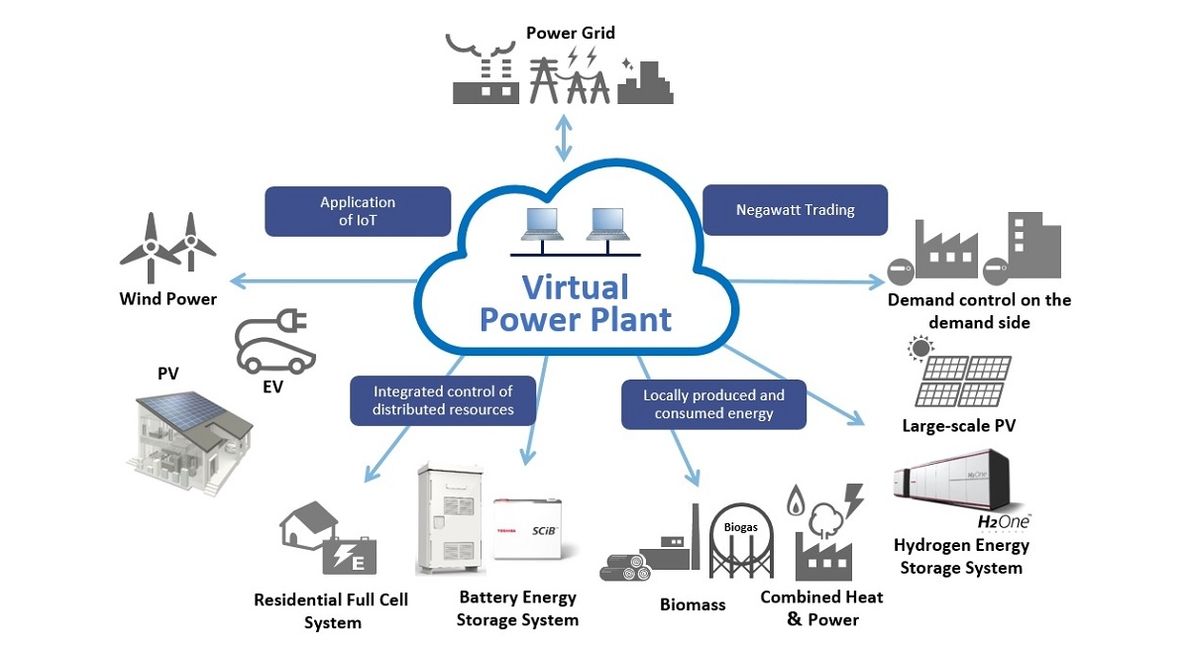
Figure 5: VPP Examples. Source: DTC Energy Solutions Working Group.
As shown by the Regional Comparisons, VPPs are being deployed globally and in a variety of configurations to enable flexibility, market competition, resilience and sustainability of DERs.
In North America, the Digital Twin Consortium (DTC) Technology Showcase introduced the concept of “Buildings as Batteries,”[4] where digital twins of commercial buildings were modeled and dispatched like virtual storage units to support grid flexibility. Simultaneously, California’s advanced demand-side programs are leveraging consumer IoT devices and the OpenADR protocol to coordinate residential smart grid resources. These systems, enhanced by AI-driven analytics, also enable real-time load curtailment during peak pricing events, helping both utilities and consumers manage cost and stability.
Across Europe, VPPs are playing a critical role in grid stabilization, enabling frequency regulation markets with tools such as predictive battery discharging. Countries, for instance Italy, are also using VPPs to manage demand side flexibility through coordinated control of the EV charging infrastructure and HVAC/heat-pump systems, creating aggregated virtual loads that can be curtailed in response to grid demands.
In Australia, energy autonomy scenarios are being tested. Microgrids, serving remote or island communities, are being integrated into a VPP architecture using digital twin-based forecasting. These systems allow for local resilience by maintaining energy balance and stability, even when disconnected from the main grid.
Japan has matured VPPs into fleet-level orchestration platforms, particularly in the integration of solar-plus-battery systems. These assets are being coordinated in real-time to participate in the country’s electricity spot-pricing market, demonstrating the commercial viability of decentralized trading and autonomous dispatch. This forms the backdrop for the Renewable Energy Aggregation Project, as described in more detail below.

Japan Renewable Energy Aggregation Project
Japan has developed a coordinated Virtual Power Plant (VPP) system to address the increasing integration of renewable and distributed energy resources (DERs) into its national power grid. This system allows a wide range of decentralized assets—such as solar photovoltaics, wind turbines, battery energy storage systems (BESS), electric vehicles (EVs) and demand-side response units—to be aggregated and controlled virtually as if they were a single power plant. The goal is to optimize energy balance, ensure grid stability and enhance the responsiveness of the electricity market to variable energy supply and demand patterns.
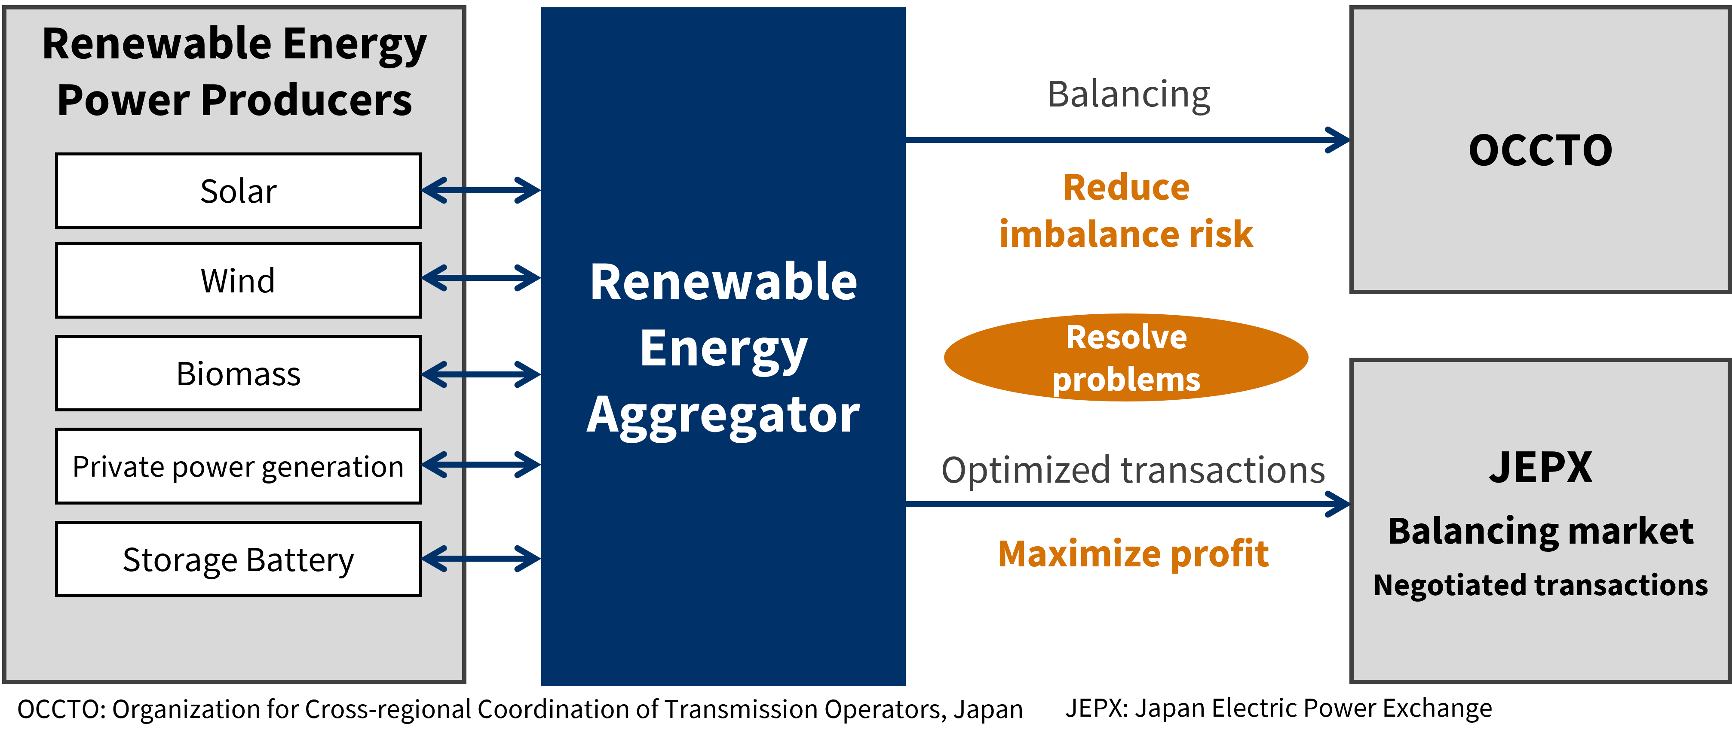
Figure 6: Japan Renewable Energy Aggregation. Source: DTC Energy Solutions Working Group.
At the core of the VPP system in Japan is a combination of advanced energy management technologies, including IoT-enabled devices, real-time data communication and AI-driven forecasting tools. These tools allow operators to monitor and predict energy production and consumption patterns, execute control commands to DERs and participate in multiple energy markets. The VPP interfaces with the nation’s Feed-in Premium (FIP) system, enabling producers to sell electricity based on market price signals while earning incentives and contributes to balancing markets by providing frequency regulation and supply-demand adjustment services.
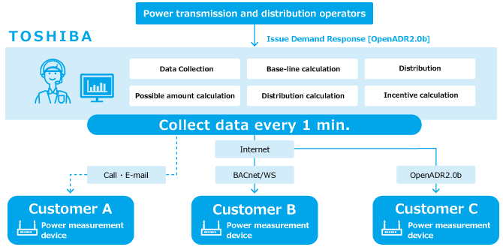
Figure 7: Toshiba VPP Operation. Source: DTC Energy Solutions Working Group.

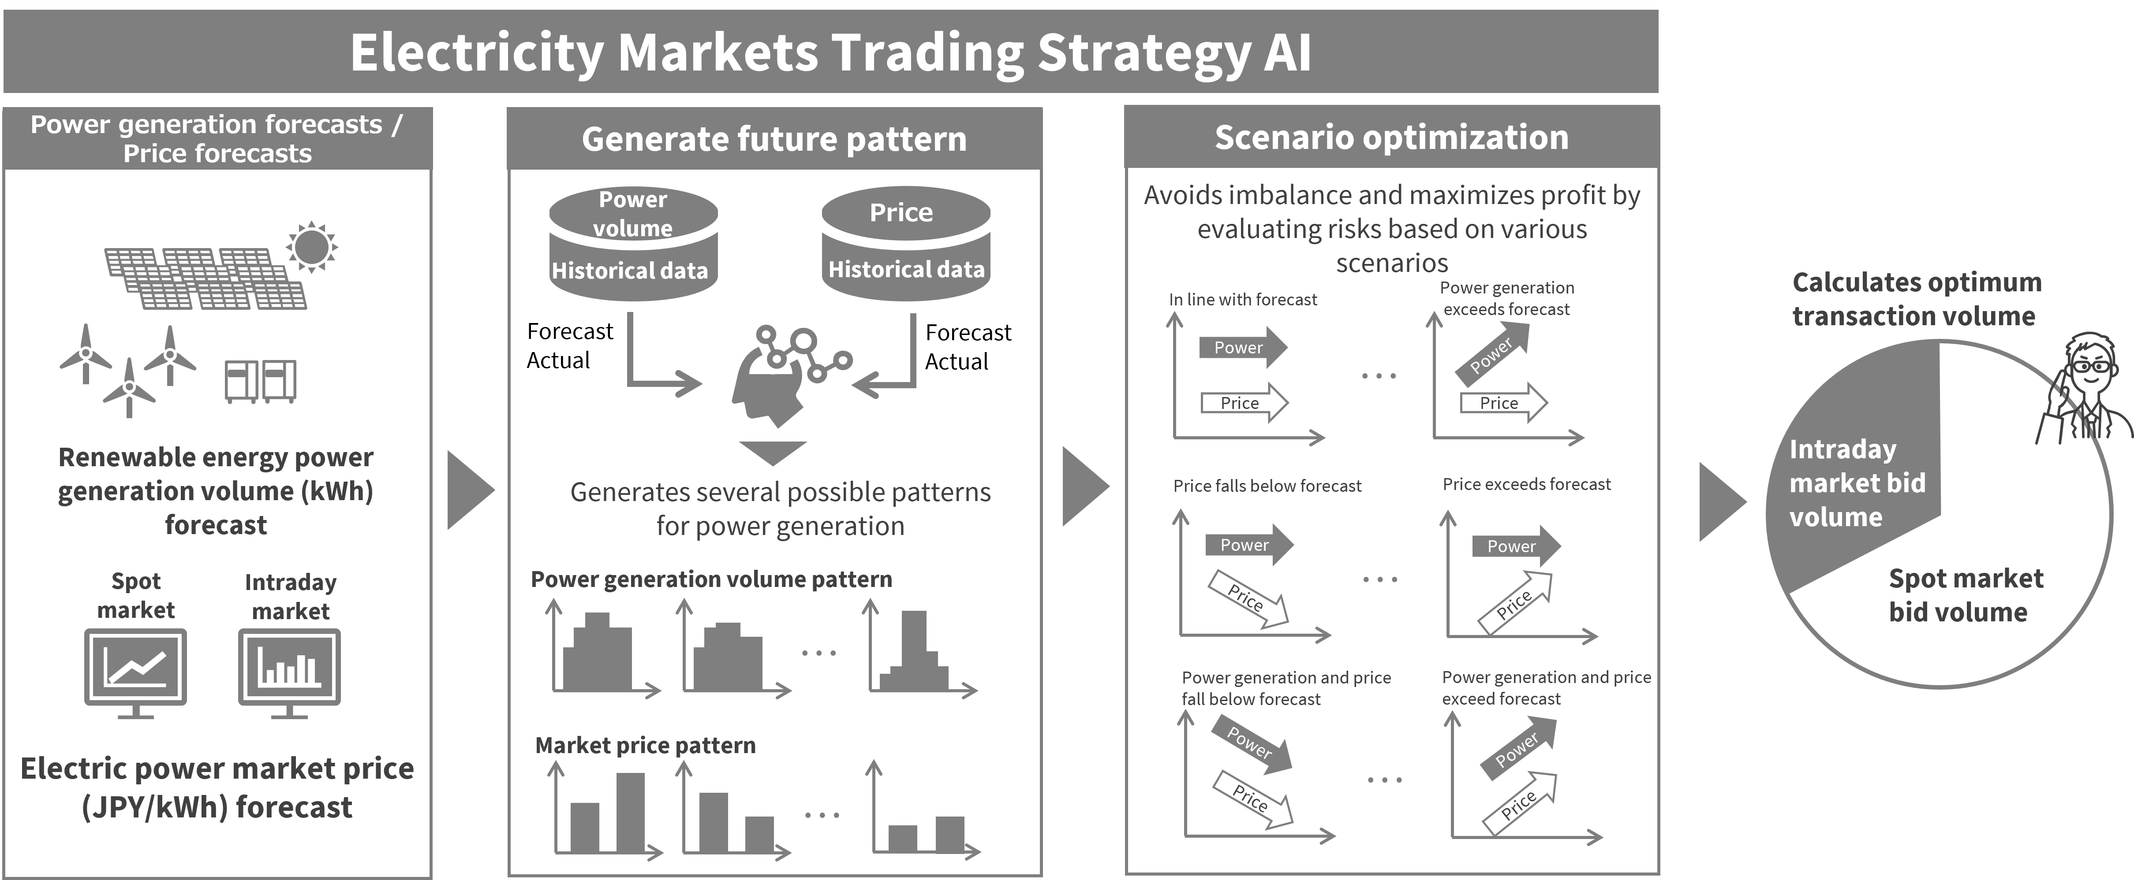
Figure 8: Trading Strategy. Source: DTC Energy Solutions Working Group. AI
This VPP framework supports the Japanese government's carbon neutrality goals by improving the efficiency and flexibility of the power system. Through collaborative public-private demonstration projects, the VPP has proven effective in reducing grid imbalances, increasing the value of distributed renewable generation and enhancing resilience in local communities. As the system matures, it is expected to expand further in functionality, with greater interoperability, higher DER participation and integration with next-generation grid services across Japan.

References
[1] Industry IoT Consortium. “Industrial Internet Reference Architecture IIRA, version 1.10”. Industry IoT Consortium, November 7, 2022. https://www.digitaltwinconsortium.org/wp-content/uploads/sites/3/2024/10/IIRA-v1.10.pdf
[2] DTC-IIC Digital Twin Interoperability Working Group. “System-of-systems Models Enabling Interoperability for Value Creation”, Digital Twin Consortium and Industry IoT Consortium. November 13, 2024. https://www.digitaltwinconsortium.org/wp-content/uploads/sites/3/2024/10/System-of-systems-Model-for-Value-Creation-2024-09-13-1.pdf
[3] Industry IoT Consortium. “Three Tier IoT Distributed Energy Resource Pattern”. Industry IoT Consortium, March, 9 2023. https://www.iiconsortium.org/wp-content/uploads/sites/2/2023/03/Patterns-IoT-Distributed-DER-030923.pdf
[4] Agile Fractal Grid, “Buildings as Batteries”. Digital Twin Consortium, March 10, 2022. https://www.digitaltwinconsortium.org/wp-content/uploads/sites/3/2022/10/Buildings-as-Batteries.pdf
[5] GORENSTEIN DEDECCA, J. et al. (2025). Increasing Flexibility in the EU Energy System; Policy Department for Transformation, Innovation and Health Directorate-General for Economy, Transformation and Industry Authors: João GORENSTEIN DEDECCA, Mohammad ANSARIN, Csinszka BENE, Timo VAN DELZEN, Luc VAN NUFFEL and Henjo JAGTENBERG PE 769.347 - March 2025 https://www.europarl.europa.eu/RegData/etudes/STUD/2025/769347/ECTI_STU(2025)769347_EN.pdf
[6] Eco-wise. First Official CEN Blueprint to create a Digital Product Passport now available – Businesses Now Have a Head Start. https://www.eco-wise.co.uk/blog/first-official-cen-blueprint-to-create-a-digital-product-passport-now-available
[7] Digital Twin Consortium, “Platform Stack Architectural Framework”. Digital Twin Consortium, 2023. https://www.digitaltwinconsortium.org/resources/public-download/platform-stack-architectural-framework.htm
[8] Digital Twin Consortium, “Digital Twin Capabilities Periodic Table”. Digital Twin Consortium, 2025. https://www.digitaltwinconsortium.org/capability-model/capability-model-download.htm

Authors & Legal Notice
Copyright © 2025, Digital Twin Consortium®, a program of Object Management Group, Inc. (“OMG®”). All other trademarks in this document are the properties of their respective owners.
All copying, distribution and use are subject to the limited License, Permission, Disclaimer and other terms stated in the Digital Twin Consortium Policies & Procedures, as posted on the legal area of the DTC website. If you do not accept these Terms, you are not permitted to use the document.
This document is a work product of the Digital Twin Consortium (Working Group/Task Group/Tiger Team) name, chaired by Name (Organization), Name (Organization) and Name (Organization).
Authors: The following persons contributed substantial written content to this document: Daniel Young (Toshiba America, Inc.), Tim Farnam (Toshiba Europe, Ltd.) and John Reynolds (Agile Fractal Grid).
Contributors: The following persons contributed valuable ideas and feedback that significantly improved the content and quality of this document: Name (Organization), Name (Organization) and Name (Organization).
Technical Editor: Dan Isaacs (DTC CTO) oversaw the process of organizing the contributions of the above Authors and Contributors into an integrated document.

